- Use Case Diagram

The main actors :
Student,Instructor, and Admin.

The key Use Cases :
-Student Use Cases:
Browse available Courses,Enroll in Course,Complete Lessons,Take Quizzes, and Earn Certificates.
-Instructor Use Cases:
Create and Manage Courses,Upload Lessons,and Design Quizzes
-Admin Use Cases:
Manage Users,Approve or Remove Courses, and Monitor Platform Analytics.

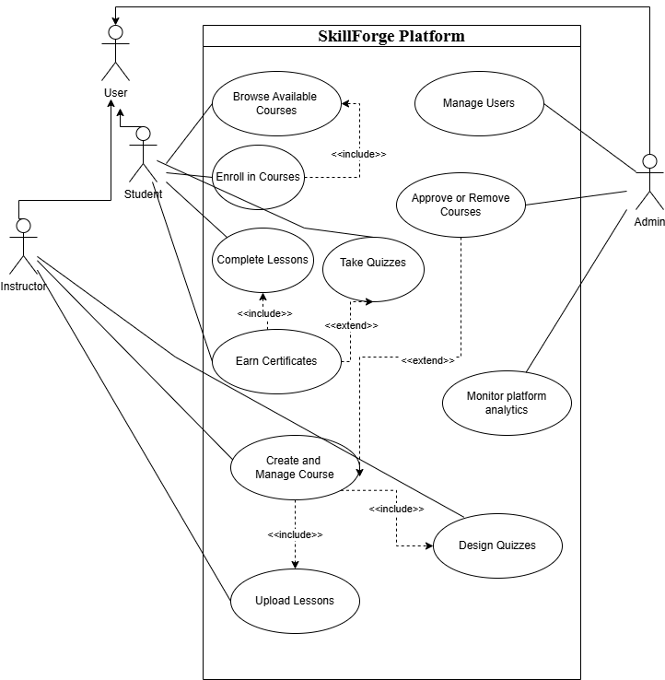

This Use Case Diagram represents the SkillForge learning platform and the interactions between different types of users and the system. The actors include Students, Instructors, and Admins, which all inherit from a general User role. Students can browse and enroll in courses, take quizzes, and earn certificates. Instructors are responsible for creating and managing course content, while Admins maintain the platform and approve newly created courses. The diagram illustrates the system’s functional requirements and the dependencies between major use cases.

Description of each use case
-Browse Available Courses : Allows students to explore and search for courses offered on the platform before enrolling.
-Enroll in Course :Enables students to register for a selected course in order to access its contents and activities.
-Complete Lessons: Students can view and finish lesson materials as part of their learning progress in the enrolled course.
-Take Quizzes :Allows students to attempt quizzes to evaluate their understanding of the course content.
-Earn Certificate : Students receive a certificate once they have successfully completed all lessons and passed required quizzes.

-Create and Manage Courses: Instructors can create new courses and modify or update existing ones, including course information .
-Upload Lessons: Instructors can upload lesson content such as text, videos, or files for students to learn from.
-Design Quizzes : Instructors can create and organize quizzes with questions to assess student learning.

-Manage Users : Admins can add, update, or remove users, and control their access permissions on the platform.
-Approve or Remove Courses : Admins review newly created courses and decide whether to approve them for publishing or remove inappropriate content.
-Monitor Platform Analytics : Admins can track and analyze platform performance, user activity, and course statistics for management decisions.

2. the sequence diagram :

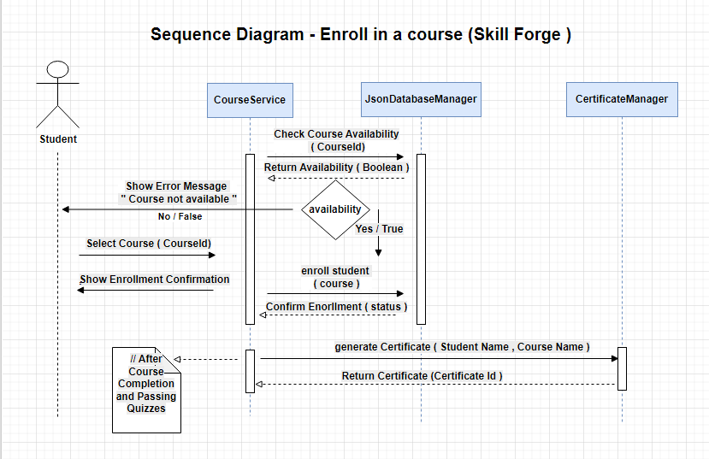

this sequence diagram shows how an user ( student ) request a Course enrollment from Course Service which check if the Chosen course is available in the jsondatabase or not then record it and after completion of the course a certificate is generated by Certificate manager

